# **Technical Document & Solution Structure**

## **Solution Structure**

I have implemented 3-tier Architecture as the below

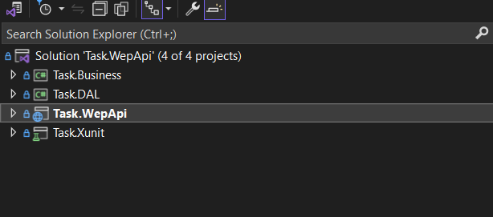

### **Application**

* **Task.DAL:** this layer will contains :
  + Repository Implementations for the entity.
  + Migrations.
  + Entity Mapping (Fluent API).
  + The entity
* **Task.Business:** this layerwillcontain services or business implementations ,helper services like logger ,DTO,AutoMapper.
* **Task.wepApi:** this layerwillcontain:
  + **Controller** that represents the endpoints.
  + **Middlewares** like ExceptionHandlingMiddleware and RequestHandlingMiddleware.
  + **Program.cs** that contains general configurations.

### **Tests**

* **Task.Xunit:** this layerwillcontain the Implementations Unit Test

## **Technologies and tools**

1. ASP .Net 8
2. SQL Server 2022
3. Visual Studio 2022 as IDE
4. Github as Source Control
5. Entity Framework Core 8.0.6
6. XUnit.Framework as Unit-test Project

## **Design patterns:**

1. Repository pattern
2. Unit of Work
3. Inversion of Control (IoC) and Dependency injection (DI)

## **Assumptions:**

1. We can use Github copilot
2. before you can run the project you should change ConnectionString, install .net 8 and SQL Server.
3. before you can run the Tests you should change ConnectionString of Test database in the FIxture.
   1. **Total time spent**

|  |  |
| --- | --- |
| Setup environment and Architecture | 2 Hours |
| Implement Task + Unit Test | 2 Hours |
| Documentation | 1Hour |
| Docker image + GitHub pipeline | 1Hour |
| Logger | 1Hour |
| Middlewares | 2Hour |
| Caching | 1Hour |